Steps in ToTEM software

1. Installer

You can run this software on Windows or Linux with or without a CUDA environment. Here's how to run it on Windows and Linux (Ubuntu) with a CUDA environment.

1.1 WINDOWS

1.1.1 CUDA

Open <https://developer.nvidia.com/cuda-downloads> to install ‘cuda 11 version’, then type ‘nvcc-v’ at the terminal. Installation is successful if display as Fig. 1-1,

Figure 1-1: Install CUDA on your PC.

1.1.2 Source code

Please run mex_cuda.m first! And Then, run ToTEM_submit_v1.m.

1.1.3 MCR (option)

Open https://www.mathworks.com/products/compiler/matlab-runtime.html to install the ‘MATLAB Runtime Version 2020b (9.9) Version’. Please choose the version on ‘Windows 64-bit’.

Double-click ‘ToTEM.exe’ to run it.

1.2 Ubuntu

1.2.1 CUDA

Open https://developer.nvidia.com/cuda-downloads to install ‘cuda 11 version’, Then type ‘nvcc-v’ at the terminal. If the terminal has CUDA 11 version information, installation is successful.

1.2.2 Source code

Run the shell, go to the ‘bin’ director of Matlab and type ‘sh matlab’ to run matlab.

Run mex_cuda.m first and then run ToTEM_submit_v1.m.

1. Usage

2.1. Load materials

Firstly, click Crystal in the upper left corner of the software, then click Load a PDB Crystal in the submenu, select the material to be imported. Secondly, enter the Debye-Waller factor of each element in the small box, and click OK after input.

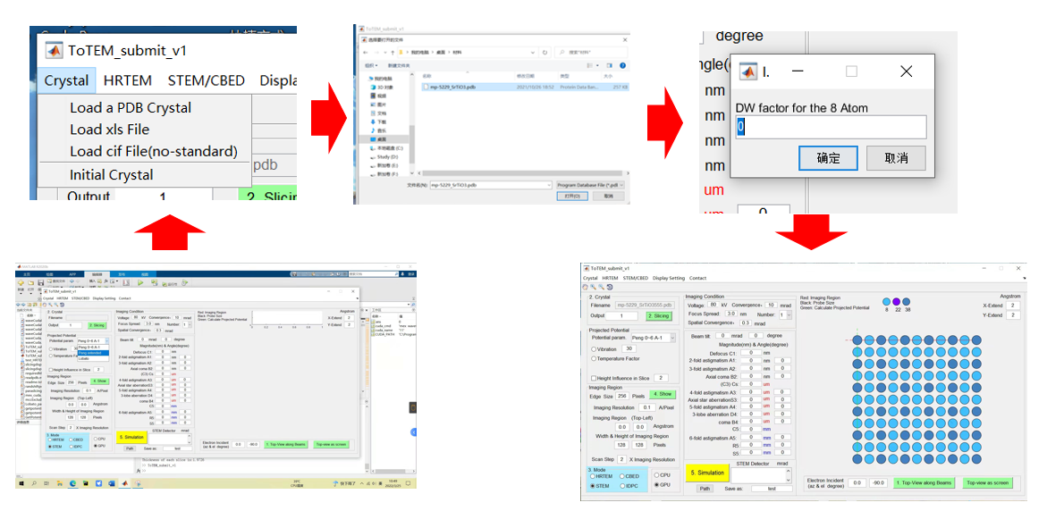

Figure 2.1: Load materials

2.2. Set sliced conditions

(i) Set the slice number and the virtual thickness.

(ii) Pick some slices or export via 3D Show.

**Total SliceNum**: total number of slices

**Atom size**: atom size for displaying.

**Virtual thickness:**

**Top**: increases the vacuum area on the upper surface of the sample.

**Bottom**: increase the vacuum area on the lower surface of the sample.

**Projected Sum**: select part of the slices to display by projection.

**Pick Some slices**: pick some slices to simulate. For example: '2 3 5(1) 3(5:7)'. Some slices will be transmitted in order as following:

2 3 1 1 1 1 1 5 6 7 5 6 7 5 6 7

**Slice thickness**: the thickness of each slice.

**3D Show**: show the whole crystal after slicing and output it for further simulation.

**Pick Some Slices**: Select some slices to build a new crystal and output it for further simulation.

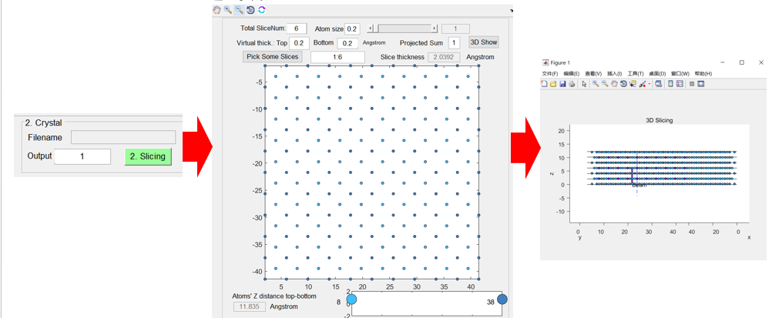

Figure 2.2: Set the sliced conditions

2.3. Potential calculation

The calculation of the potential can select the parameters of Peng or Lobato. If the resolution of simulation image exceeds 1/ (2 × 12) = 0.0417 Å/pixel (lower than it), the correction method is recommended. Other parameters are described as follows:

**Vibration**: atoms will vibrate according to its temperature factor, and the repeat time of vibrations is input in its edit box.

**Temperature Factor**: potential will be attenuated via adding a damping function according to its temperature factor of each atom.

**Height influence in Slice**: Potential will be assigned upwards (downwards) to neighboring slices, which is in its edit box and the recommended value has been output after slicing crystal.

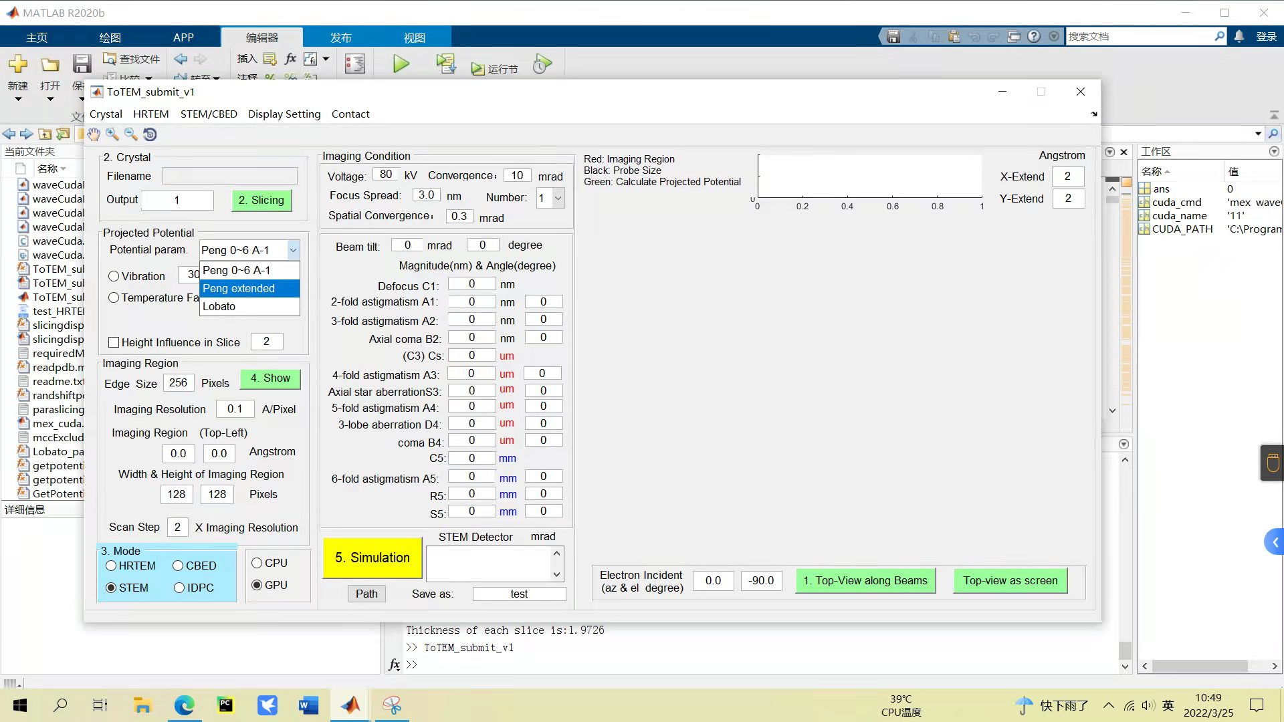

Figure 2.3: Potential calculation conditions

2.4. Imaging area and mode selection

At the bottom of the interface, you can choose the simulation mode, there are four modes: HRTEM, CBED, STEM, IDPC. You can choose to use CPU or GPU for simulation

i) Parameters about STEM simulation are as follows:

**Edge Size**: size of incident probe and one probe is shown in black region when shown.

**Imaging Resolution**: the image resolution of the simulated potential and incident probe.

**Imaging Region：（Top-Left）**: top left position of simulated STEM image. For example, if (0, 0) is entered, the starting position of the red box is at the position where the coordinates are (0, 0).

**Width & Height of Imaging Region**: indicates the width and height of the simulate STEM image (red region).

**Scan Step**: scan step size, which is an integer. And it will be multiple with the value in Imaging Resolution edit box to represent the sampling rate of simulated STEM image.

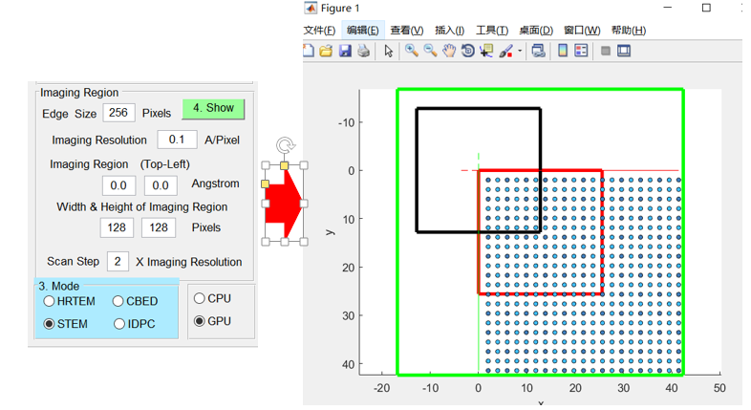

Figure 2.4: Imaging area and its setting for STEM simulation

ii) Parameters about HRTEM simulation are as follows (See Figure 5):

**Edge Size**:Simulate a bigger potential (green region) via extending the imaging region along four sides.

**Imaging Resolution**: Image resolution of the simulated HRTEM image.

**Imaging Region**：**（Top-Left）**: top left position of red box. For example, if (0, 0) is entered, the starting position of the red region is at the position where the coordinates are (0, 0).

**Width & Height of Imaging Region**: Width and height of the HRTEM image (red region).

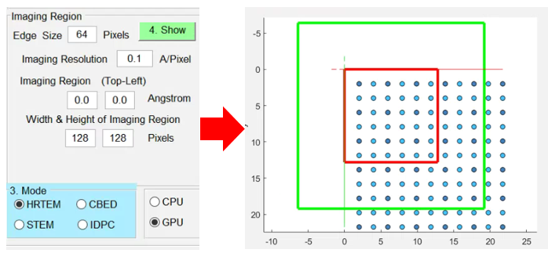

Figure 2.5: Imaging area and its setting for HRTEM simulation

iii) Parameters about CBED simulation are as follows:

**Size**: The size of the red box and it is the imaging region of CBED.

**Imaging Resolution**: the image resolution of the simulated potential.

**Imaging Region**：**（Top-Left）**: top left position of red box. For example, if (0, 0) is entered, the starting position of the red box is at the position where the coordinates are (0, 0).

Green region represents the region of the simulated potential which has been extended along each side with a fix value of 4 Angstrom.

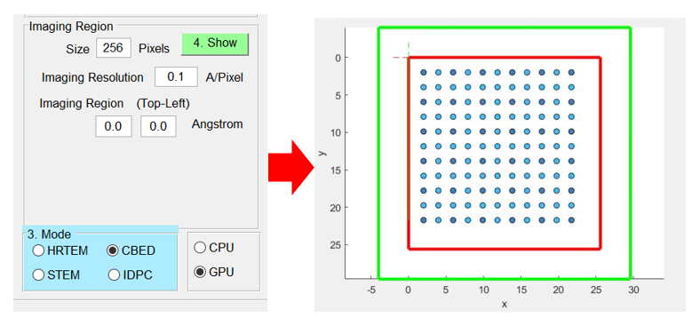

Figure 2.6: Imaging area and its setting for CBED simulation

2.5. Simulation conditions

Aberrations and properties of incident probe should be input and Scherzer focus will be given in terminal window after input Cs value.

**Number** represents the calculation times of chromatic dispersion; other parameters can be input according to the simulation conditions.

**Path** is used to select a path to save result. In the edit box, files will be named as it.

Specially for STEM or IDPC-STEM simulation, the STEM detector will be input, such as “20, 300; 40, 100” via using ‘;’ interval.

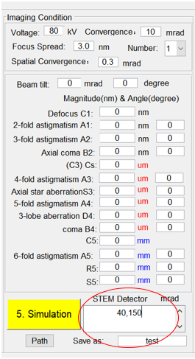

Figure 2.7: Other simulation conditions

Edited by Fang Lin

April 21st, 2022